DACCOM – PRESCRIBING ANALYSIS
EPACT INFORMATION UPTO FEBRUARY 2007

The analysis below gives an overall performance against prescribing budget allocated to the PBC practices. It also includes the performance indicators used to monitor cost-effective prescribing. New indicators will be developed in conjunction with areas of FRP outlined and agreed.

1. Performance against prescribing budget

Practice Code | Name | Budget | Forecast Over/Under Spend £ | Forecast Over/Under Spend % | Cumulative Spend to Date per 1,000 ASTRO-PUs | % Variance 2005/06 vs 2006/07 Yr on Yr Outturn
E82643 | Archway Surgery | £308,865 | -£25,350 | -8.21% | £20,638 | -2.25%
E82032 | Bennetts End Surgery | £1,966,958 | £3,722 | 0.19% | £24,453 | 2.80%
E82076 | Boxwell Road Surgery | £641,656 | -£7,890 | -1.23% | £21,325 | 1.97%
E82051 | Everest House Surgery | £1,537,473 | £240,359 | 15.63% | £28,396 | 2.57%
E82022 | Fernville Surgery | £1,539,862 | £2,361 | 0.15% | £25,715 | 0.12%
E82652 | Gossoms End Elderly Care Unit | £288,603 | £17,836 | 6.18% | £26,327 | -5.80%
E82050 | Grove Hill Medical Centre | £445,143 | -£12,959 | -2.91% | £22,733 | 6.83%
E82066 | Haverfield Surgery | £318,973 | -£42,240 | -13.24% | £17,958 | -5.62%
E82640 | Highfield Surgery | £445,380 | -£24,619 | -5.53% | £22,957 | 0.55%
E82129 | Kings Langley Surgery | £1,272,934 | -£60,247 | -4.73% | £21,280 | 2.03%
E82009 | Lincoln House Surgery | £1,381,630 | £57,838 | 4.19% | £27,355 | 2.58%
E82028 | Milton House Surgery | £977,150 | -£91,577 | -9.37% | £20,598 | -2.85%
E82091 | Parkwood Drive Surgery | £2,057,072 | £21,042 | 1.02% | £25,318 | 3.89%
E82001 | Rothschild House Surgery | £1,845,963 | £311,558 | 16.88% | £27,375 | 6.17%
E82094 | The Manor Street Surgery | £940,983 | -£109,766 | -11.67% | £19,224 | -4.65%
E82131 | The New Surgery | £378,154 | £6,354 | 1.68% | £23,046 | 2.64%
E82663 | The Surgery - Dr Sepai | £422,142 | -£6,618 | -1.57% | £21,029 | 1.86%
E82070 | Woodhall Farm Medical Centre | £240,220 | -£30,504 | -12.70% | £20,434 | -0.53%
E82644 | 2 Coleridge Crescent | £155,392 | -£8,228 | -5.30% | £22,988 | 0.49%
Practices Outside of Locality |  | £0
Out of Hours |  | £22,550
Contingency |  | £205,000
Locality Total |  | £17,392,139 | £27,622 | 0.16%

PERFORMANCE AGAINST COST-EFFECTIVE INDICATORS

- STATINS – EoE TARGET = 80%

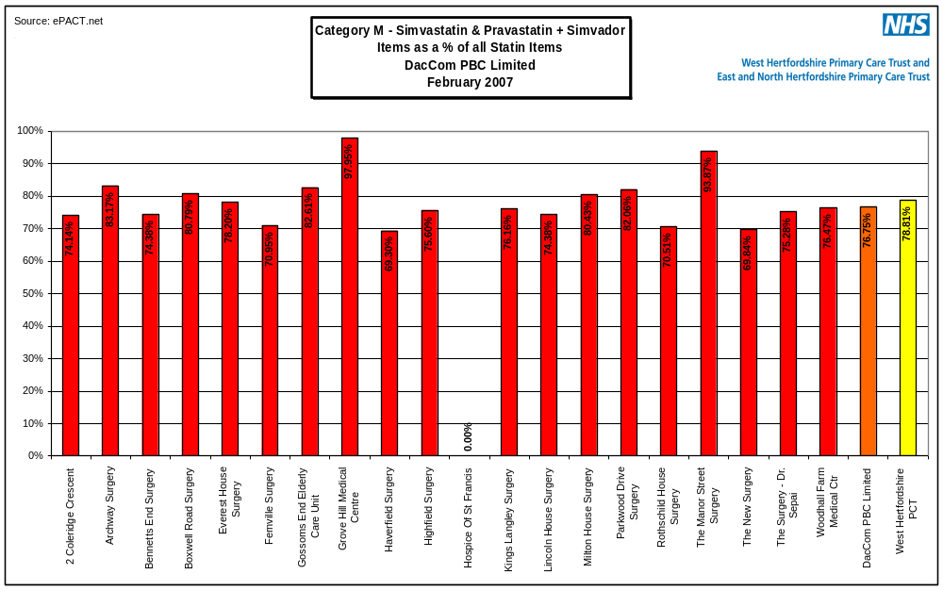

Compared to other localities

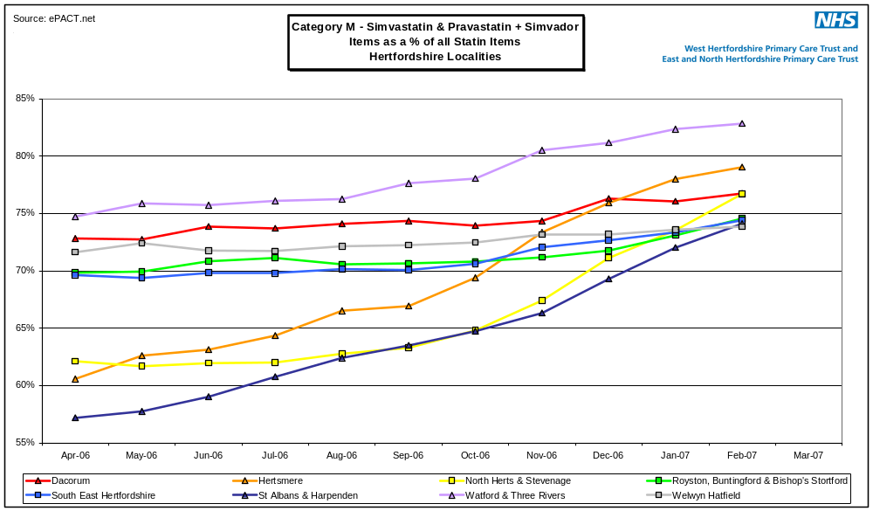

2. Cost-effective Proton Pump inhibitor choices: EoE Target: 90% of PPI

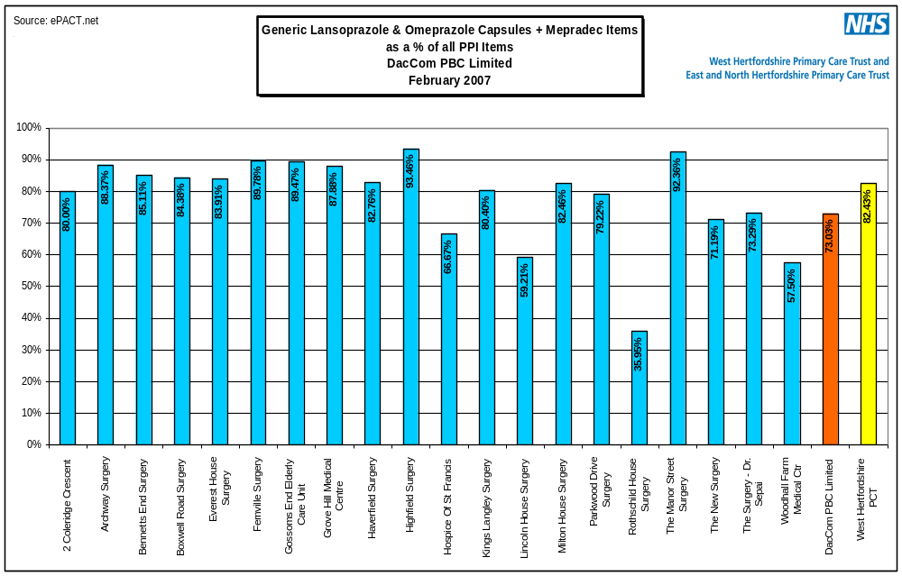

Compared to other localities

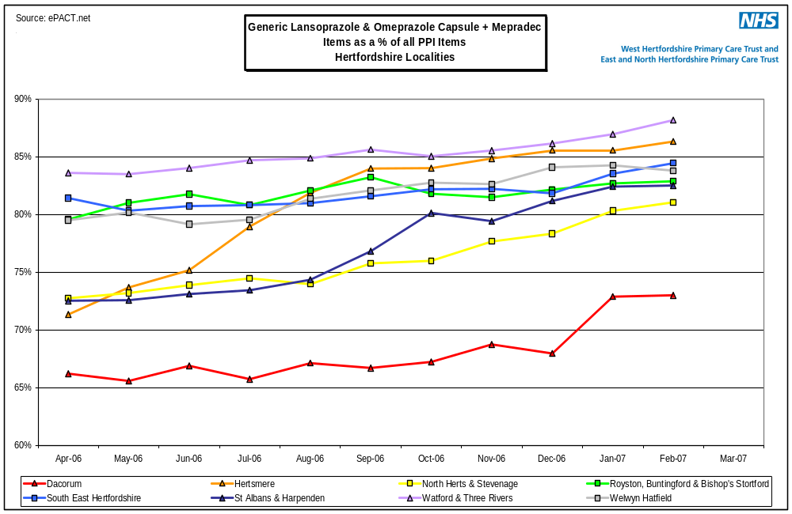

- Generic Amlodipine : EoE Target: 95%

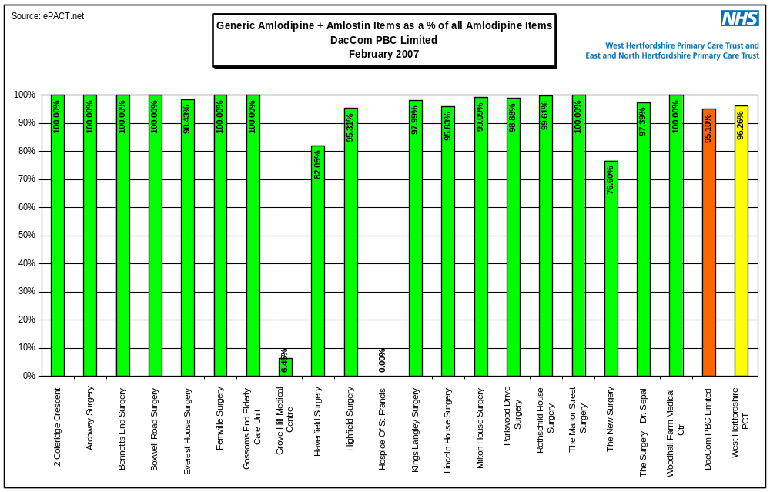

Compared to other localities

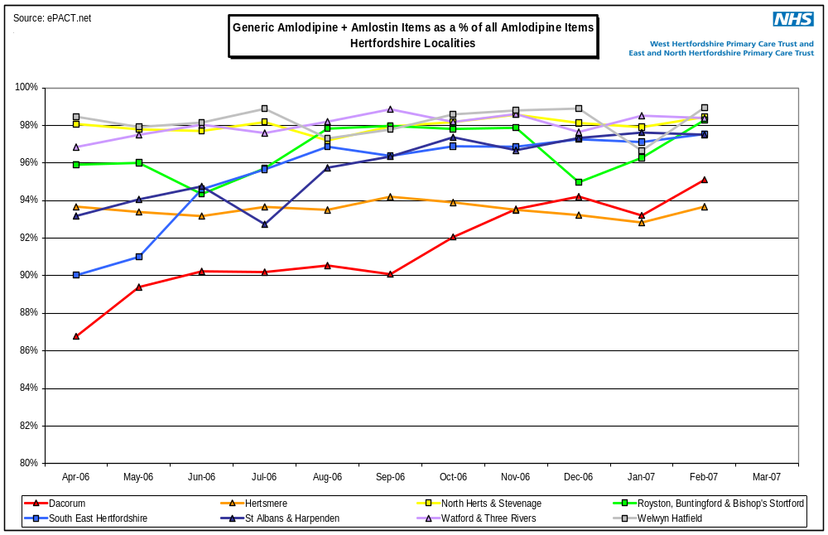

- Generic Ramipil capsules: EoE Target: 95%

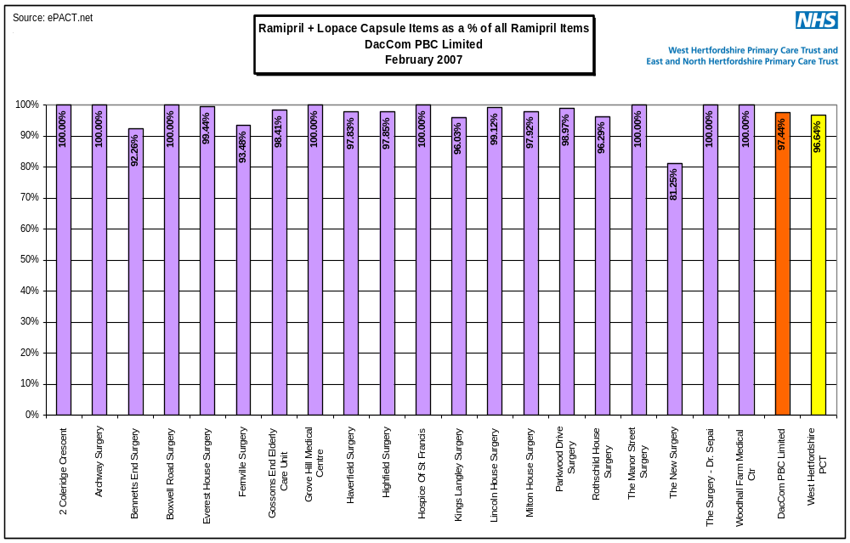

Compared to other localities

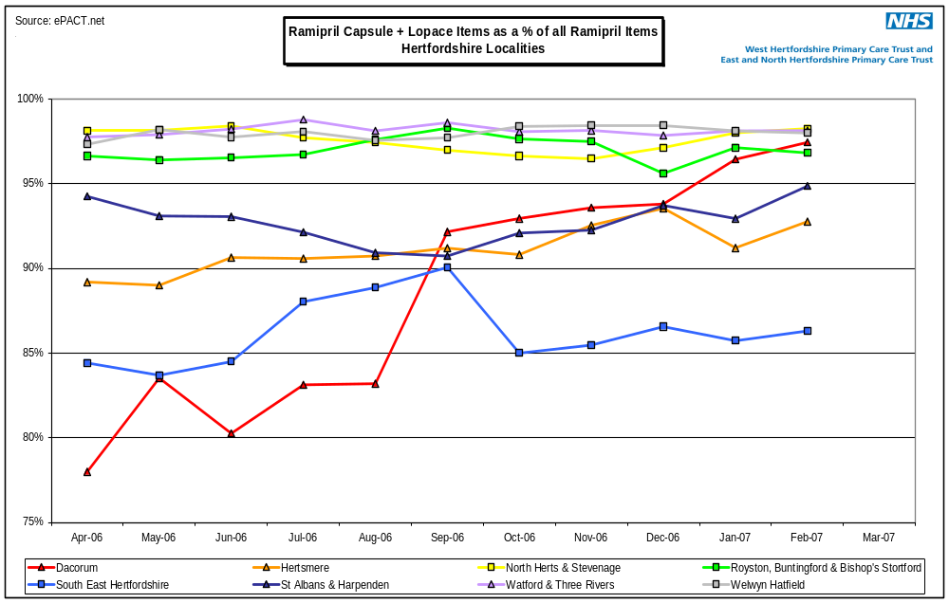

- Captopril, Enalapril, Ramipril capsules and Lisinopril as a % of all ACEI : East of England Target: 90%

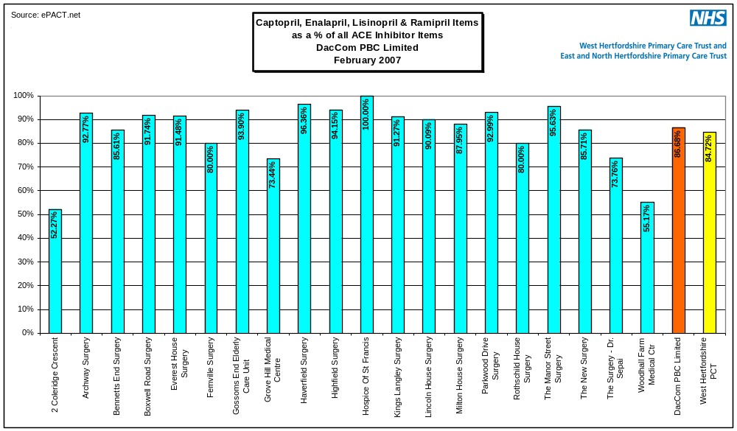

Compared to other localities

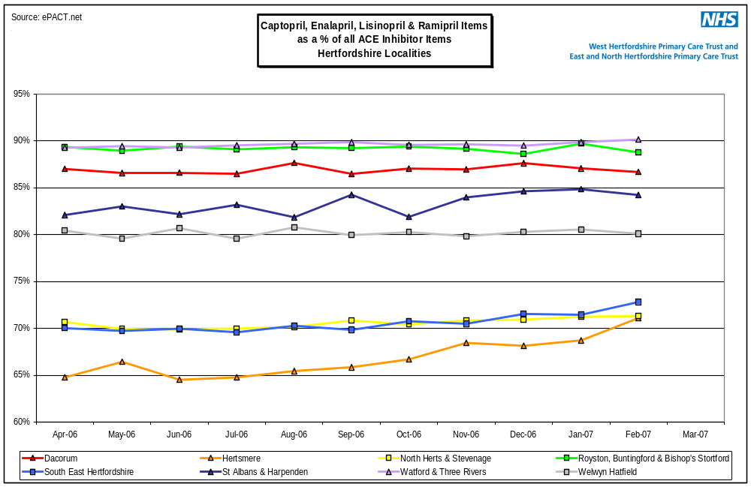

- Sartans as a % of all ACEI

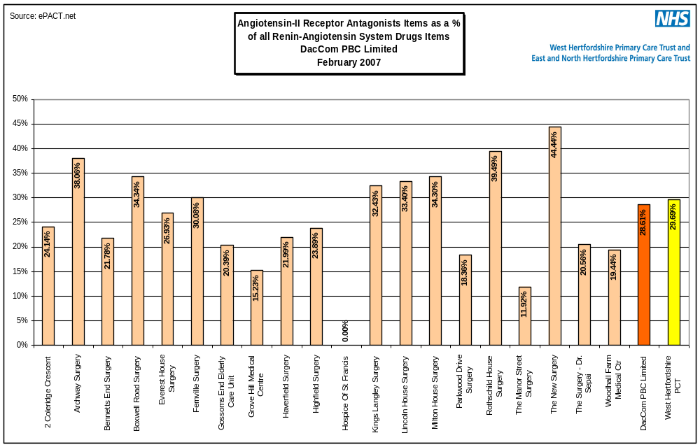

Compared to other localities

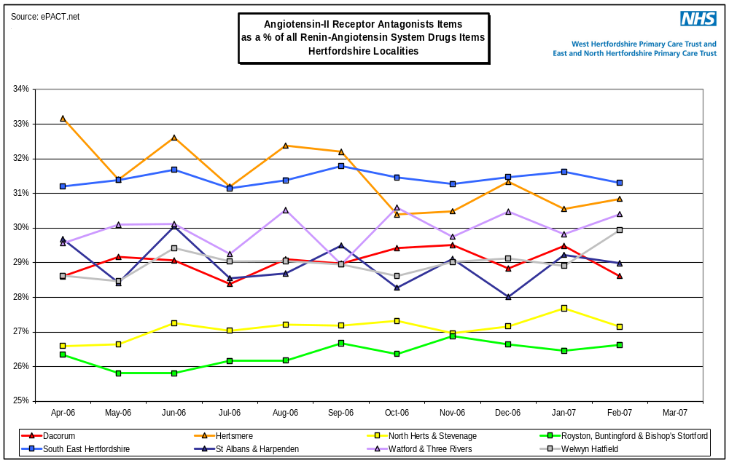

- Coxibs as a % of all NSAIDs

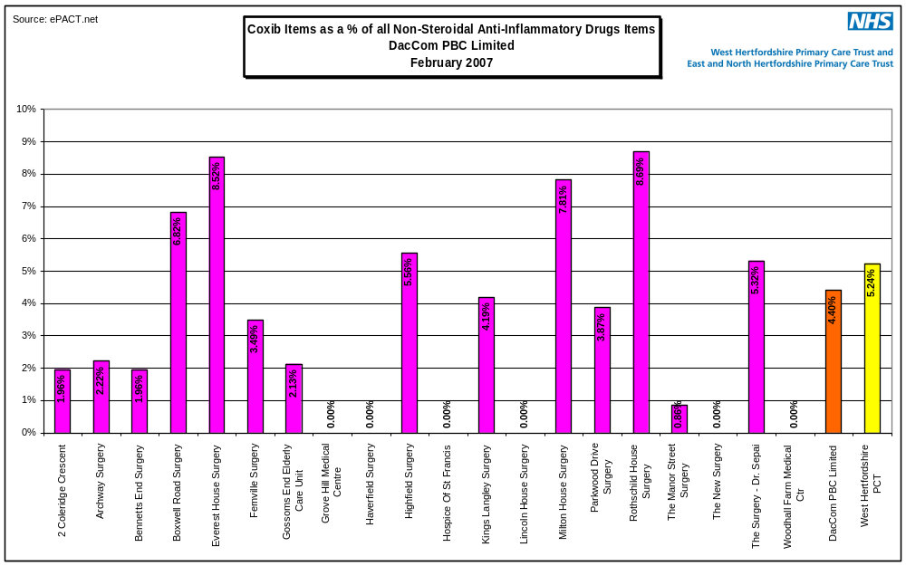

Compared to other localities

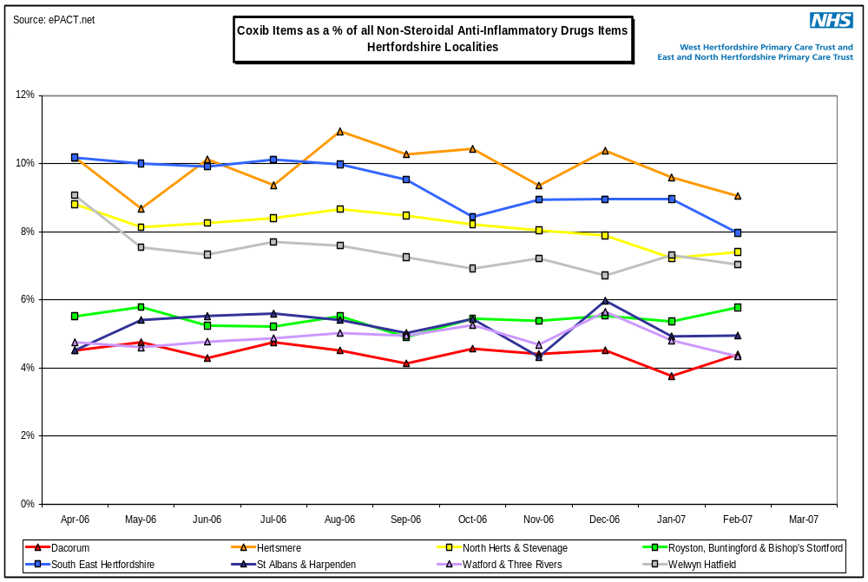

- Candesartan as a % of all AIIRAs



